PRODUCT REQUIREMENTS · DATA MODEL · API CONTRACT
RunLah
Runner Live Tracking App
PRD, ERD & API Contract — Version 2.0
Status | Draft for team review
Version | 2.0 (replaces v1 of 3 Oct 2026)
Date | 9 Oct 2026
Authors | Qirah (backend, admin web) · Arep (mobile)
Target | R1 live on App Store and Google Play by 31 Dec 2026

What's new in v2
- Race Insights (§6): post-race and live analytics modelled on the KLSCM 2026 results page by RunPix that Arep shared, built on our own data.
- Benchmark of every RunPix feature and how RunLah does it better (§5).
- Goals with measurable targets (§3), non-functional requirements (§10), feature IDs and priorities (§7).
- ERD grows from 16 to 20 tables; new Results & Insights API with conventions, examples and error codes.
- Proposed release rebalance that puts Insights before OCR and video. Needs Qirah and Arep's OK (§17, Q1).

Document control

Version history
Version | Date | Author | Changes
1.0 | 3 Oct 2026 | Qirah | First draft: roles and modes, v1 scope, tracking architecture, stack, ERD (16 tables), API, build order, risks.
2.0 | 9 Oct 2026 | Qirah, with Claude | Added Race Insights and a RunPix benchmark based on the KLSCM 2026 result Arep shared. Added goals and metrics, personas, user flows, NFRs, feature IDs, metric definitions with a worked example, 4 new tables, Insights API, API conventions, open questions, glossary. Redrew all diagrams. Proposed release rebalance.

Review and sign-off
Name | Role | Status
Qirah | Backend, realtime, admin web, watchOS | Author
Arep | Flutter app, maps, Wear OS | To review: §5–7 and the release proposal in §16

How to read this document
Part | Sections | For
A. Product | 1–9 | What we're building and why: scope, Race Insights, flows, ideas
B. Technical design | 10–15 | How it works: NFRs, architecture, tracking, stack, ERD, API
C. Plan | 16–18 | Build order, risks, open questions, glossary

Rows and labels marked NEW are new in v2. Tables with CHANGED have new columns.

Contents
Document control
1. Summary
2. Problem and opportunity
3. Goals, non-goals and success metrics
4. Users, roles and modes
5. Benchmark: KLSCM 2026 results page (RunPix)
6. Race Insights NEW
6.1 Data it needs
6.2 Metric definitions
6.3 Features
6.4 Privacy in Insights
7. Feature scope and releases
8. Key user flows
9. Idea pool
10. Non-functional requirements
11. System architecture
12. Tracking and insights architecture
12.1 Tracking sources
12.2 How the pieces work
12.3 Results and insights job NEW
13. Tech stack and work split
14. Data model (ERD)
15. API contract
15.1 Conventions
15.2 Endpoints
15.3 Points batch (the hottest endpoint)
15.4 Example: finish card
15.5 Realtime channels (Reverb)
15.6 Error codes
16. Build order
17. Risks and open questions
17.1 Risks
17.2 Open questions
18. Glossary

PART A
Product
What RunLah is, who it's for, what ships in each release, and the new Race Insights module.

1. Summary
RunLah is a live tracking app for runners and the people cheering them, inspired by the KLSCM app. Runners are tracked by phone GPS, an LTE smartwatch, or a checkpoint camera reading their bib. Supporters follow them on a live map with ETA and get a push when they pass a checkpoint. Organizers set up and run the event from an admin web.
After the finish, every runner gets Race Insights: where they placed overall, by gender and in their category, how fast each section was, how many runners they passed, and where they were on the course when the winner crossed the line. While the race is still on, the same numbers show live as provisional.
The first public release (R1) ships on iOS and Android by 31 Dec 2026.

Decisions carried over from v1
- Three roles: Runner, Cheer, Organizer.
- Two modes: official event (bib, checkpoints, ranking) and free run (no event, share by link).
- Three tracking sources: phone GPS, LTE smartwatch GPS, and checkpoint cameras reading bib numbers (OCR). No RFID mats in v1.
- Mobile: Flutter, one codebase for iOS and Android. Watch apps are native (SwiftUI, Kotlin).
- Backend: Laravel API with Laravel Reverb for realtime, plus an admin web for organizers.
- One v1 scope, built in order. The December release is phone-only.

New decisions proposed in v2
- Add Race Insights (§6), the results experience runners share after a race.
- Accept an official timing CSV from the organizer, so Insights also cover runners who never opened our app (F27).
- Record the actual gun time per race in the admin web (F05). Gun time, start delay and gun-based ranks depend on it.
- Ship Bahasa Malaysia and English from R1 (F36).

2. Problem and opportunity

The problem
On race day, supporters don't know where their runner is. They wait at the finish guessing, miss them at cheer spots, and refresh a timing site that only updates when a runner crosses a mat. Runners finish with one time and one rank, and the story of their race (the fast second quarter, the 1,000 people they overtook) is lost.

What the KLSCM 2026 results page shows
Arep shared a KLSCM 2026 half marathon result on RunPix (timing by Dirigo Events). It turns a finish time into a story: placings drawn as a crowd of runners, overtakes before and after halfway, section speeds, and "where were you when the winner finished". The link Arep received came through Instagram (utm_source=ig), so runners clearly share these pages.
RunPix only works after the race and only from timing mats. RunLah has live GPS, so we can show the same insights during the race, with exact positions, and connect them to the people cheering.
Scale reference: KLSCM 2026 half marathon
11,664 finishers (3,910 women, 7,754 men). Median net time 2:51:40. This is the field size a results job must handle in minutes, and the reason v2 adds a results table (§14).

3. Goals, non-goals and success metrics
# | Goal | Metric | Target | Measured at
G1 | Runners are tracked reliably | Phone-tracked runners whose track has no gap over 60 s | ≥ 95% | R1 pilot, 14–20 Dec
G2 | Cheer sees runners live | Delay from GPS fix to dot moving on Cheer's map | p50 < 10 s  p95 < 30 s | R1 pilot
G3 | Organizer setup is quick | Time to create an event with GPX, bib CSV and checkpoints | ≤ 30 min | R1 pilot
G4 | Results are ready fast | Last finisher crosses → full Insights available | ≤ 10 min | First R2 event
G5 | Runners love their results | Finishers who open Insights; of those, who share a card | ≥ 60%  ≥ 20% | First R2 event
G6 | The app is stable | Crash-free sessions | ≥ 99.5% | Store consoles, from R1

Non-goals for v1
- RFID mats and live timing-company feeds. (A CSV of final results is in scope; live feeds are not.)
- Payments and race registration.
- Training plans, coaching, or a social feed.
- Certified official timing. Our results are unofficial until the organizer publishes them.

4. Users, roles and modes

Personas
Persona | Who | Needs most
Casual runner | 10 km weekend runner, phone in an armband | Battery that lasts, a live link for family, simple splits
Competitive runner | Sub-1:40 half marathoner who checks every number | Accurate net time, category place, section pace, who they beat
Cheer | Parent, partner or friend on the course | When to stand where, a push at each checkpoint, finding the runner after
Organizer | Race director with a small team | Fast setup, SOS visibility, publishing results without a big timing budget

Roles
One account can act as Runner and Cheer. Organizer is a separate permission granted per event.
Role | What they do | Where
Runner | Joins an event with a bib or starts a free run, gets tracked, sees splits, results and Insights | Mobile app, watch
Cheer | Follows runners by name, bib, QR or share link; sees live map, ETA and ranking; sends cheer messages | Mobile app, public web link
Organizer | Creates events, uploads the route, imports bibs, places checkpoints, fires the gun, publishes results | Admin web

Modes
Mode | Has | Does not have
Event | Bib, categories, checkpoints, ranking, Race Insights, finish video, e-cert | —
Free run | Live tracking, share link, cheer messages, personal stats | Bib, ranking, checkpoints, Race Insights

Both modes use the same activities record. An activity with a participant_id is an event run; without one it is a free run.

5. Benchmark: KLSCM 2026 results page (RunPix)
Every feature on the page Arep shared, what it shows, and how RunLah will do it. Example values are from that half marathon result (bib 34144, M 20-29).
RunPix feature | What it shows | RunLah version | ID
Place line (Finish tab) | Place overall, by gender and division; finishers behind; % ahead; Net/Gun toggle. 172nd of 11,664 | Same, plus Top % to one decimal (1.5%, not "1%"), shared places for ties, and a provisional version live during the race | F18
Gender compare | % of the other gender you finished ahead of. Shows 100% when the true value is 99.7% | Exact %, never rounded up to 100% unless nobody of that gender beat you | F18
Start delay | Gun time minus net time: 0:39 | Same; Cheer also sees "crossed the start 0:39 after the gun" live | F18
Division / Nation toggle | Place in age group, or among runners of your nationality | Same, from nationality in the bib CSV | F18
You passed / passed you | Overtakes before and after halfway: 1,094 passed, 4 passed you | Same per half, plus per checkpoint and a place-by-checkpoint chart | F21
Average pace and speed | 4:34 /km, 7:21 /mile, 13.2 km/h | Same; units follow the user's km/mile setting | F18
Who's who | Finishers by gender (34% / 66%) and median net time 2:51:40 | Same, plus a finish-time histogram with a "you are here" marker | F19
Section speed | Speed and pace for each quarter: 13.2, 13.8, 12.9, 12.8 km/h | Per quarter, per checkpoint, or per km for GPS runners | F20
Where were you? | Your estimated spot on the course map when the male winner finished; Friends; Next | Exact GPS position when we have it; more moments: gun, each winner, your finish, a friend's finish, cutoff | F23
Drone view | Animated dots crossing the finish near you, coloured by division and gender | Same from finish passes; grows into a full-course race replay later | F28, F29
Comparer | Search another runner and compare | Up to 4 runners side by side with a gap chart at each checkpoint | F25
Ghost left / right | The runners who finished just ahead of and behind you | Same, with the gap in seconds and a one-tap follow for next race | F24
Share | Links to social networks | Ready-made 9:16 story and 1:1 image cards with a deep link back | F26

What RunPix can't do and RunLah can
- Live tracking with ETA, and Insights that update during the race.
- Cheer notifications at checkpoints, and cheer messages.
- SOS to the organizer.
- Free runs outside events.
- Finish-line video clip per runner.
- Insights for small events that have our virtual checkpoints but no timing company.

6. Race Insights NEW
Race Insights is the results experience for every finisher of an event race. It has four tabs (Finish, Speed, Where, Compare) plus a share card, in the app and on a public web page. While the race is live it shows provisional numbers, refreshed every 60 s; once the organizer publishes, the screen is labelled Official.
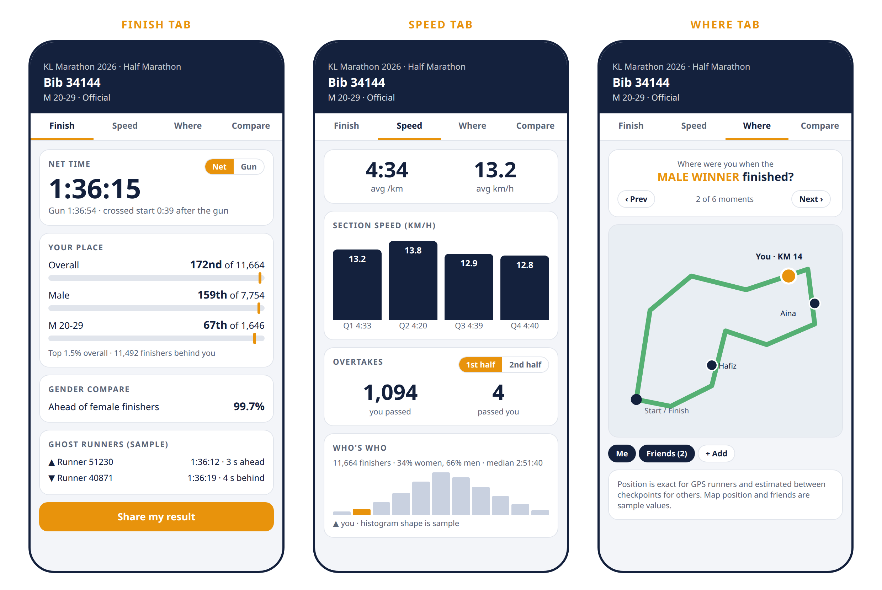
Figure 1. Race Insights wireframes with real values from bib 34144. Ghost runners, histogram shape and map positions are sample values. Not final UI.

6.1 Data it needs
- A start pass and a finish pass for each runner, in checkpoint_passes (from GPS, OCR, manual entry, or an imported CSV).
- The actual gun time per race, races.gun_at (F05).
- Intermediate passes for sections and overtakes. More checkpoints give finer insights; GPS runners get per-km detail from track_points.
- Gender, birth year (for category) and nationality per participant, from the bib CSV.

6.2 Metric definitions
Each metric is defined once here; app, web and share card all read the same stored values. The example column rebuilds bib 34144's KLSCM 2026 result from these rules, and matches what RunPix shows.
Metric | Definition | Example (bib 34144)
Net time | Finish pass − start pass | 1:36:15
Gun time | Finish pass − races.gun_at | 1:36:54
Start delay | Start pass − gun_at (equals gun − net) | 0:39
Place | 1 + finishers in the group with a lower time. Ties share a place. Basis is net or gun, per toggle | 172nd overall · 159th male · 67th M 20-29
Finishers behind | Finishers in the group with a higher time | 11,492 · 7,595 · 1,579
Top % | (place − 1) ÷ finishers in the group, one decimal | 1.5% · 2.0% · 4.0%
Other-gender compare | Other-gender finishers with a higher time ÷ all other-gender finishers | 3,897 ÷ 3,910 = 99.7%
Average pace, speed | Net time ÷ race distance | 4:34 /km · 13.2 km/h
Section speed | Section distance ÷ (pass at section end − pass at section start) | 13.2 · 13.8 · 12.9 · 12.8 km/h
You passed | Runners who crossed the section start before you and the section end after you, by clock time | 1,094 before halfway
Passed you | Runners who crossed the section start after you and the section end before you, by clock time | 4 before halfway
Place by checkpoint | Your place in clock-time order of crossing at each checkpoint | Line chart
Median net time | Middle net time of all finishers in the race | 2:51:40
Where were you | Your route distance at clock time T: from GPS if present, else linear between your passes before and after T | Pin on the map
Ghost left / right | The finishers with the next lower and next higher net time | Name, time, gap

Overtakes use clock time, not elapsed time, because they describe who was physically ahead on the road. A runner who started 3 minutes behind you and finished 1 minute faster never passed you if you crossed every point first.
Runners without a pass at both ends of a section are left out of that section's counts, and the screen says "based on N runners".

6.3 Features

F18 Finish card · R1
Shows. Net and gun time with a toggle, start delay, place overall / gender / category / nation with "of N", finishers behind, Top %, other-gender compare, average pace and speed, ghost runners (R2).
Rules. Rank basis defaults to the race's rank_basis. Labelled Provisional until the organizer publishes.
Done when. Values for a 50-runner pilot match a hand-checked spreadsheet exactly.

F19 Who's who · R2
Shows. Finisher count, gender split, median net time, and a finish-time histogram with a marker for you.
Done when. Histogram and median match a spreadsheet for a real 10,000-row CSV.

F20 Section speed · R2
Shows. Speed and pace per section as bars, with a toggle between quarters and checkpoint-to-checkpoint. GPS runners also get a per-km chart.
Rules. A quarter ends at the checkpoint nearest to 25%, 50% and 75% of distance; GPS runners use exact distances.
Done when. Section times add up to net time within 1 s.

F21 Overtakes and place by checkpoint · R2
Shows. "You passed" and "passed you" for the first and second half, the same for every section, and a chart of your place at each checkpoint.
Rules. Computed for all runners at once by sorting crossings and counting inversions (O(N log N) per section), not runner by runner.
Done when. Counts match a brute-force check on a 2,000-runner sample.

F23 Where were you · R2
Shows. A course map with your position at a chosen moment: the gun, male winner finish, female winner finish, your finish, a friend's finish, the cutoff. Next and Prev cycle through moments. Friends shows the runners you follow on the same map.
Rules. Positions for non-GPS runners are marked as estimated.
Done when. Estimated positions are within one checkpoint gap of a GPS runner's true position.

F24 Ghost runners · R2
Shows. The runners who finished just ahead of and just behind you, with gaps in seconds and a follow button.
Rules. Runners who hide their name show as "Runner 34144".
Done when. Ghosts are correct at the first and last place in the field.

F25 Comparer · R2
Shows. Pick up to 4 runners by name or bib. Side-by-side times, places and section speeds, plus a gap chart at each checkpoint.
Done when. Comparing a runner with themselves shows zero gaps everywhere.

F26 Share card · R2
Shows. A 1080×1920 story card and a 1080×1080 square card with name, time, place, Top % and one highlight (e.g. "passed 1,094 runners"). A deep link opens the runner's Insights in the app or on the web.
Rules. Rendered on the server, cached in media as share_card, regenerated when results change. BM and English.
Done when. A card posts to an Instagram story from both iOS and Android.

F27 Official results import · R2
Shows. Organizer uploads the timing company's results CSV in the admin web: bib, name, gender, category, nation, gun time, net time, and optional split columns.
Rules. Rows become checkpoint passes with source import, which win over every other source. Bad rows go to an error report the organizer can download.
Done when. A real 10,000-row CSV imports and computes in under 10 minutes.

F28 Drone view · R3
Shows. An animation of runners crossing the finish within ±60 s of you, coloured by your category, other men and women, with 1×–10× playback.
Done when. Order of crossing in the animation matches finish pass order.

F29 Race replay · Later
Shows. The whole race animated on the course map for all runners or only the ones you follow.
Done when. Not scheduled.

6.4 Privacy in Insights
- Only finishers of a race with public results appear in another runner's Insights.
- A runner can set their results name to bib only ("Runner 34144"). Places still count; the name is hidden everywhere.
- Where-were-you and Friends show only runners you follow, and only if their privacy setting allows it.
- Raw GPS tracks are never shown to other runners, only derived positions at a moment.

7. Feature scope and releases
Releases: R1 31 Dec 2026 · R2 Feb 2027 · R3 Apr 2027 · R4 May 2027 · Later not scheduled. R3 and R4 dates are part of the proposal in §16. Priority: Must blocks the release; Should slips to the next release if late; Could is nice to have.
ID | Feature | Role | Release | Priority
Accounts and setup
F01 | Sign up, login, profile (email, Google, Apple) | All | R1 | Must
F02 | Create event, upload route GPX, categories, schedule | Organizer | R1 | Must
F03 | Import participants and bibs by CSV, incl. gender, birth year, nationality | Organizer | R1 | Must
F04 | Place checkpoints on the route (virtual geofences) | Organizer | R1 | Must
F05 | Record gun time per race with one tap in admin NEW | Organizer | R1 | Must
F36 | Bahasa Malaysia and English NEW | All | R1 | Must
Running and tracking
F06 | Join event by bib number + verification code | Runner | R1 | Must
F07 | Start, pause, finish a run with background GPS | Runner | R1 | Must
F08 | Free run with share link | Runner | R1 | Must
F09 | Offline queue for GPS points, battery saver mode | Runner | R1 | Must
F10 | Privacy setting: public, link only, off | Runner | R1 | Must
F11 | SOS button sending location to organizer | Runner | R1 | Must
F12 | View route and schedule | Runner, Cheer | R1 | Must
F35 | Apple Watch and Wear OS apps (LTE live, GPS-only sync later) | Runner | R4 | Should
Cheering
F13 | Add runner by name, bib or QR scan | Cheer | R1 | Must
F14 | Live map of followed runners with pace and ETA | Cheer | R1 | Must
F15 | Push when a runner passes a checkpoint or finishes | Cheer | R1 | Must
F30 | Cheer messages to a runner | Cheer | R2 | Should
Results and Race Insights
F16 | Live ranking and unofficial results, overall and by category | All | R1 | Must
F17 | Race statistics: splits, pace chart, distance | Runner | R1 | Must
F18 | Finish card: net/gun, start delay, places, Top %, gender compare NEW | Runner, Cheer | R1 | Should
F19 | Who's who: field stats, median, histogram NEW | All | R2 | Should
F20 | Section speed NEW | Runner | R2 | Should
F21 | Overtakes and place by checkpoint NEW | Runner | R2 | Should
F23 | Where were you, with Friends NEW | Runner, Cheer | R2 | Should
F24 | Ghost runners NEW | Runner | R2 | Could
F25 | Comparer NEW | All | R2 | Could
F26 | Share card for stories and feed NEW | Runner, Cheer | R2 | Should
F27 | Official results import (CSV) NEW | Organizer | R2 | Must
F33 | Official results publish, e-certificate | Organizer, Runner | R2 | Must
F28 | Drone view (finish-line replay) NEW | Runner, Cheer | R3 | Could
F29 | Full race replay NEW | All | Later | Could
Cameras and media
F31 | Checkpoint camera app reading bib numbers (OCR) | Organizer | R3 | Must
F32 | Finish-line video clip per runner | Runner, Cheer | R3 | Should
F34 | Selfie frames | Runner, Cheer | R3 | Could

F22 is retired: gender compare is part of F18. Out of v1: RFID mats, live timing-company feeds, payments and race registration.

8. Key user flows
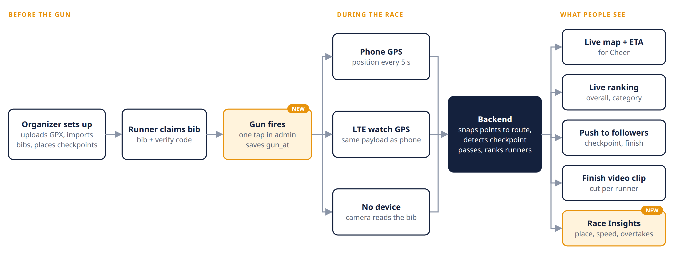
Figure 2. Race day, from setup to what people see.

Organizer
- Before race day: create event → upload GPX per race → place checkpoints → import bib CSV → invite staff → publish.
- Race day: tap Gun for each race as it starts → watch the live map and SOS queue → close the race when the cutoff passes.
- After: import the timing company's CSV if there is one → review → publish official results → e-certificates go out.

Runner, event day
- Claim bib with bib + verification code (any time before the race).
- Pre-race check: location permission set to Always, battery above 50%, GPS lock.
- Tap Start in the corral. Net time starts when the runner crosses the start-line geofence, not at the tap.
- Run with the screen off; points upload in batches, or queue offline.
- Finish is detected at the finish geofence. The Finish card appears as Provisional, then turns Official when the organizer publishes.

Cheer
- Add a runner by name, bib, QR on the bib, or a share link.
- Watch the live map with pace and ETA; get a push at each checkpoint and at the finish.
- After the finish, open the runner's Insights and share their card.

Free run
- Start → share link with family → stop → personal stats. No ranking, no Insights.

9. Idea pool
None of these are committed. Anything picked up moves into §7 with a release. Ideas promoted from the v1 pool or newly added are marked.
Idea | What it does | Effort | From
Live overtake counter NEW | Cheer sees "passed 37 runners since KM 10" during the race | Medium | Claude (v2)
Projected finish NEW | Live predicted finish time from current pace and course left | Low | Claude (v2)
Age-graded score NEW | WMA age-graded % so runners of different ages can compare | Low | Claude (v2)
Race passport and PBs NEW | All past RunLah races, personal bests per distance | Medium | Claude (v2)
Year-on-year NEW | Compare with your result in the same race last year | Medium | Claude (v2)
Course heatmap NEW | Organizer sees congestion and slow sections across the field | Medium | Claude (v2)
Race Wrapped NEW | End-of-year summary card: km raced, places gained, best section | Medium | Claude (v2)
Voice cheers | Cheer records a short voice note; runner hears it mid-run | Medium | Claude (v1)
Cheer spots | Good places to stand, with when your runner will pass each one | Medium | Claude (v1)
Meet me after | Runner drops a pin after finishing so supporters can find them | Low | Claude (v1)
Pacer tracking | Follow official pacers and see if your runner is ahead or behind | Low | Claude (v1)
Target time alerts | Runner sets a goal; app warns when pace drops below it | Low | Claude (v1)
Photo matching | Photographers upload photos; bib OCR tags them to each runner | High | Claude (v1)
Badges and streaks | Rewards for events finished, PBs, free runs per week | Medium | Claude (v1)
Training groups | Private leaderboard for a running club's weekly runs | Medium | Claude (v1)
Heat and weather alert | Warns runners and organizer when conditions turn risky | Low | Claude (v1)
Export to Strava | Send a finished run to Strava | Medium | Claude (v1)

PART B
Technical design
Non-functional requirements, architecture, tracking and insights pipelines, stack, data model and API contract.

10. Non-functional requirements
Area | Requirement
Live latency | GPS fix to Cheer's map: p50 < 10 s, p95 < 30 s.
Throughput | R1 sized for 1,000 concurrent live runners (≈ 200 points/s, ≈ 70 batch requests/s at 15 s batches). Must scale out to 10,000 runners (≈ 2,000 points/s) by adding API and worker nodes, no redesign.
Insights compute | One run for a 12,000-finisher race in < 60 s. Full Insights ≤ 10 min after the last finisher.
Battery | Targets, confirmed in the GPS spike: ≤ 10% per hour normal, ≤ 6% per hour in battery saver.
Offline | App keeps up to 6 hours of points offline and uploads them in order on reconnect.
Availability | 99.5% during live events. Clients fall back to 10 s polling if the socket drops.
Security | Sanctum tokens. Share tokens are 128-bit random. Staff endpoints check event_staff role. Private activities return 404, not 403.
Privacy (PDPA 2010) | Explicit location consent; default privacy is link only; delete-my-data completes within 30 days; raw point retention per Q3 in §17.
Localisation | Bahasa Malaysia and English. Times shown in the event's timezone (Asia/Kuala_Lumpur), UTC in the API. km or miles per user.
Accessibility | Text scales with the OS setting; charts never rely on colour alone; contrast at least 4.5:1.
Observability | Crash and error tracking on app and API. Race-day dashboard: points/s, socket connections, queue lag, results job duration.

11. System architecture
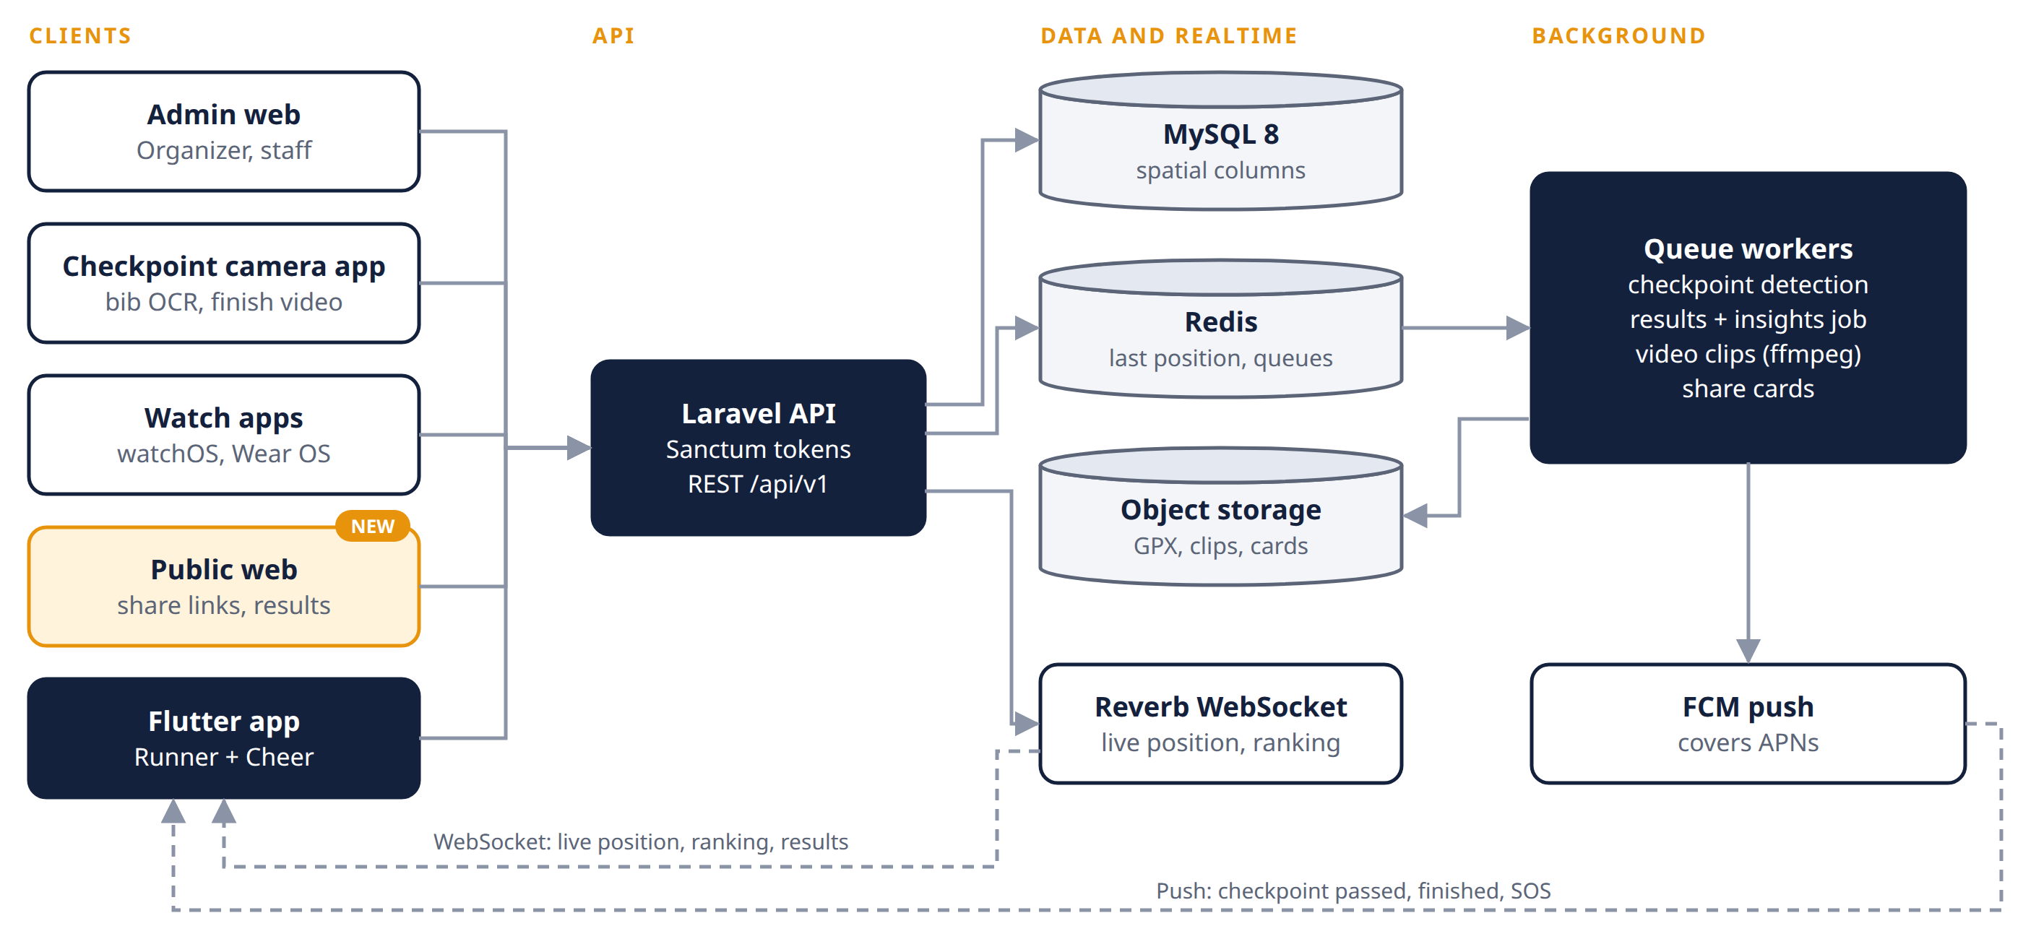
Figure 3. Five clients, one Laravel backend.
Every client talks to one Laravel API over REST. The API writes to MySQL, keeps each runner's latest position in Redis, and pushes live updates through Reverb. Queue workers do the slow work: checkpoint detection, the results and insights job, finish video clips and share cards. FCM delivers pushes on both platforms. The public web serves share links and results pages to people without the app.
Hosting needs a VPS, not shared hosting: Reverb, queue workers and ffmpeg all need long-running processes. Public results and stats are cacheable and should sit behind a CDN on race day.

12. Tracking and insights architecture

12.1 Tracking sources
Every source writes to the same two tables: track_points for raw positions and checkpoint_passes for split times. The live map never cares where a point came from.
Source | Sends | Live? | Covers
Phone GPS | Position every 5 s (15 s in battery saver), batched | Yes | Runners carrying a phone
LTE watch GPS | Same payload as phone | Yes | Runners with a cellular watch, no phone
GPS-only watch | Recorded track uploaded after the run | No | Stats only
Checkpoint camera (OCR) | Bib + timestamp + checkpoint | At checkpoints | Runners with no device
Timing CSV import NEW | Gun, net and split times per bib | No | Every finisher, after the race

12.2 How the pieces work
- Ingest. The app posts batches of points. The server snaps each point to the route and stores distance along the route in metres.
- Virtual checkpoints. When snapped distance crosses a checkpoint's distance, the server writes a checkpoint_passes row with source gps.
- Camera checkpoints. A phone on a tripod runs the checkpoint app, reads bib numbers and posts a pass with source ocr. Low-confidence reads go to a review queue in admin.
- Gun and start line. NEW The organizer taps Gun in admin, which saves races.gun_at and broadcasts gun.fired. The start checkpoint (type start) gives each runner's start pass, so net time = finish pass − start pass.
- Estimated position. A runner with no live GPS is shown at last pass distance plus pace × elapsed time, capped at the next checkpoint, and marked estimated.
- Broadcast. Reverb pushes position and pass events to followers. Clients fall back to polling every 10 s if the socket drops.
- Finish video. The finish camera records continuously in 60 s segments with server-synced time. On a finish pass, a queue job cuts 10 s before to 5 s after with ffmpeg and attaches the clip.
- The bib barcode is for race kit check-in and Cheer scan-to-follow, not for reading runners in motion; the camera reads the printed number.

12.3 Results and insights job NEW
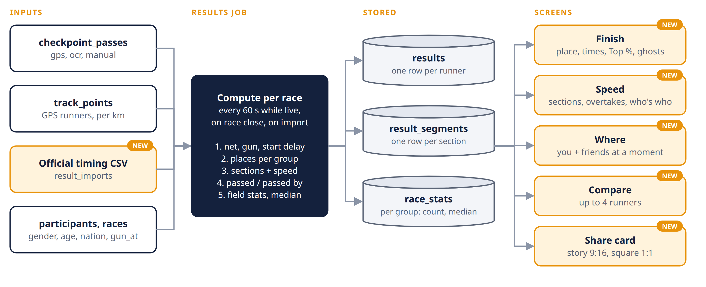
Figure 4. One job per race turns passes into stored results; screens only read.
- Triggers: every 60 s while a race is live, once when the race closes, and after each CSV import. One job per race at a time (unique lock).
- Load every runner's start and finish pass and gun time; compute net, gun and start delay.
- Rank by sorting once per group (overall, gender, category, nation) with shared places for ties.
- Sections: for each pair of consecutive checkpoints, compute duration and speed; count passed and passed-by by sorting crossings at the section start and counting inversions at the end with a Fenwick tree.
- Stats: finishers, gender split, median and histogram per group into race_stats.
- Write results, result_segments and race_stats in one transaction stamped with computed_at; clear the cache; broadcast results.updated.
Rows are replaced on every run until the organizer publishes. Publishing sets official = true and the job stops overwriting them.

13. Tech stack and work split
Layer | Choice | Owner (proposed)
API | Laravel + Sanctum tokens | Qirah
Realtime | Laravel Reverb (WebSocket); Redis for queues and last-position cache | Qirah
Database | MySQL 8 with spatial columns | Qirah
Admin web | Laravel + Blade or Inertia, MapLibre for the route editor | Qirah
Mobile app | Flutter; geolocator + a foreground service for background GPS | Arep
Maps | MapLibre with OpenStreetMap tiles | Arep
Charts NEW | fl_chart in Flutter for section bars, histogram and place chart | Arep
Localisation NEW | Flutter ARB files; Laravel lang files for push text and cards | Arep (app), Qirah (server)
Push | Firebase Cloud Messaging (covers APNs) | Arep (client), Qirah (server)
Results job NEW | Laravel queue job, plain PHP sorting and Fenwick tree | Qirah
Share cards NEW | Server-rendered PNG from templates (Intervention Image) | Qirah
Bib OCR | On-device text recognition (ML Kit) in the checkpoint app; server validates against the bib list | Qirah
Video | ffmpeg on a queue worker; object storage for clips | Qirah
Watch apps | SwiftUI (watchOS), Kotlin + Compose (Wear OS) | Qirah (watchOS), Arep (Wear OS)

The owner column is a proposal. Both test on their own devices: Qirah on iOS, Arep on Android.

14. Data model (ERD)
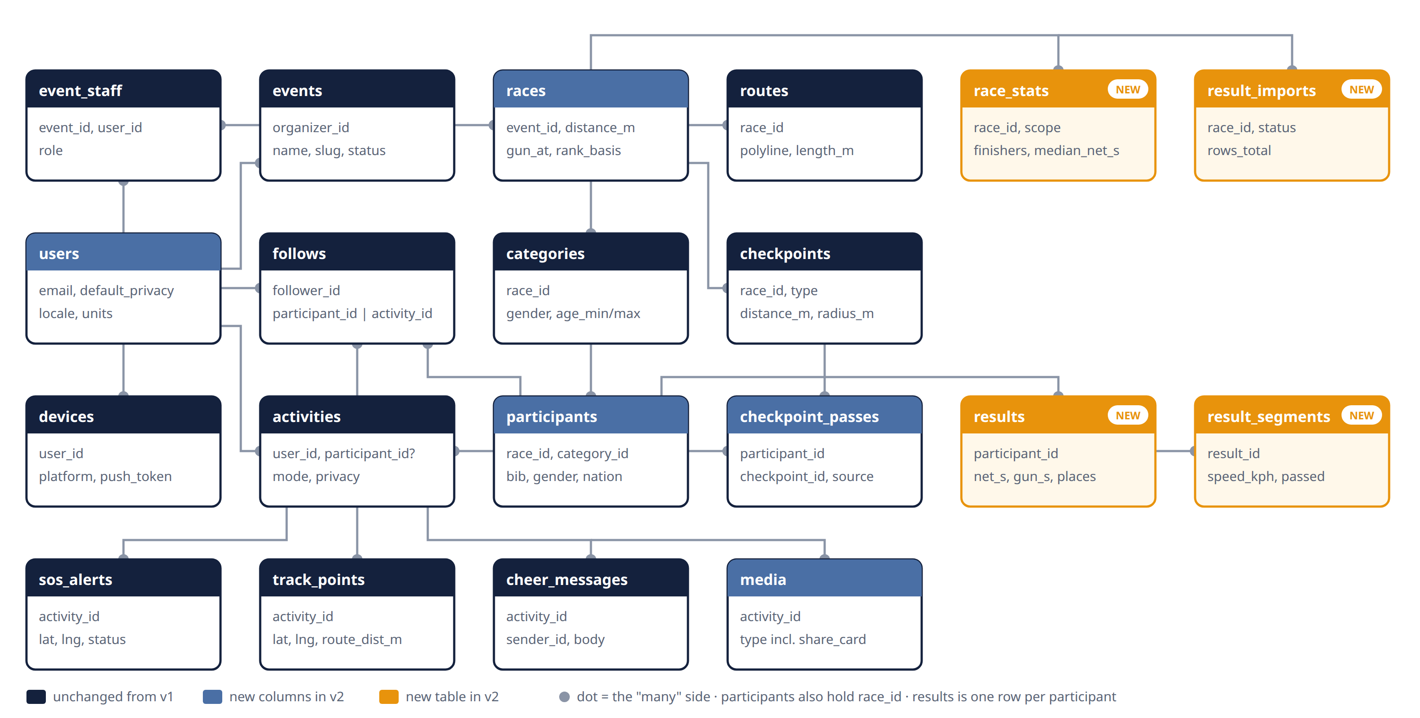
Figure 5. Twenty tables. Key columns only; see the table below for the full list.
All tables have id, created_at and updated_at; those are left out below.
Table | Key columns | Relationships
Accounts
users CHANGED | name, email, password, avatar_url, default_privacy, locale, units | —
devices | user_id, platform, push_token | belongs to user
Event setup
events | organizer_id, name, slug, starts_at, timezone, status (draft, published, live, finished) | belongs to user (organizer)
event_staff | event_id, user_id, role (admin, marshal, medic) | event ↔ user
races CHANGED | event_id, name, distance_m, start_at, cutoff_at, gun_at, rank_basis (net, gun), results_status (none, provisional, official) | belongs to event
routes | race_id, gpx_path, polyline (LINESTRING), length_m | one per race
checkpoints | race_id, name, type (start, split, finish), distance_m, location (POINT), radius_m | belongs to race
categories | race_id, name, gender, age_min, age_max | belongs to race
participants CHANGED | race_id, category_id, bib, name, verify_code, user_id (nullable until claimed), gender, birth_year, nationality (ISO 3166 alpha-3), results_name (full, bib_only) | belongs to race; claimed by user
Race day
activities | user_id, participant_id (nullable), race_id (nullable), mode (event, free), status, privacy, share_token, started_at, finished_at, distance_m, duration_s | belongs to user; optional participant
track_points | activity_id, recorded_at, lat, lng, accuracy_m, speed_mps, route_distance_m, source (phone, watch) | belongs to activity
checkpoint_passes CHANGED | participant_id, checkpoint_id, passed_at, source (gps, ocr, manual, import), confidence, elapsed_s | participant ↔ checkpoint
follows | follower_id, participant_id (nullable), activity_id (nullable), notify | user follows a participant or a free run
cheer_messages | sender_id, activity_id, body, sent_at | belongs to activity
media CHANGED | activity_id, type (finish_video, photo, frame, share_card), path, checkpoint_id, captured_at | belongs to activity
sos_alerts | activity_id, lat, lng, status (open, acknowledged, closed), handled_by | belongs to activity
Results and insights
results NEW | participant_id (unique), race_id, status (finished, dnf, dns, dq), net_s, gun_s, start_delay_s, place_overall, place_gender, place_category, place_nation, avg_pace_s_km, official, computed_at | one per participant
result_segments NEW | result_id, from_checkpoint_id, to_checkpoint_id, distance_m, duration_s, speed_kph, passed, passed_by, place_at_end | belongs to result
race_stats NEW | race_id, scope (overall, gender:F, category:12, …), finishers, median_net_s, histogram (JSON), computed_at | belongs to race
result_imports NEW | race_id, file_path, status (queued, done, failed), rows_total, rows_failed, error_report_path, uploaded_by | belongs to race

Notes
- participants exists before the runner has an account. The organizer imports bib, name and category; the runner claims it in the app with bib + verify_code.
- Unique indexes on (race_id, bib) and (participant_id, checkpoint_id). Source priority for a pass: import > ocr > manual > gps.
- track_points grows fast: about 720 rows per runner per hour at 5 s. Index (activity_id, recorded_at), partition by month, and keep each runner's latest position in Redis so the live map never queries this table.
- Changed from v1: v1 had no results table until official results needed freezing. Insights show ranks across 10,000+ runners on every screen view, so the results job writes them once per run and screens only read.
- "Of N" counts come from race_stats rows for the matching scope, so screens never count rows.

15. API contract

15.1 Conventions
Topic | Rule
Base path | /api/v1, JSON only. Breaking changes go to /api/v2; additive fields don't bump the version.
Auth | Authorization: Bearer <token> (Sanctum). Public endpoints work without a token.
Times | ISO 8601 in UTC (2026-12-06T22:30:05Z). Durations are integer seconds with an _s suffix.
Distances | Integer metres with an _m suffix. Speeds in km/h (_kph).
Pagination | Cursor-based: ?cursor=&limit= (default 50, max 100). Response: { "data": [...], "next_cursor": "..." }.
Errors | { "message": "...", "errors": { "field": ["..."] } } with the matching HTTP status (see 15.6).
Rate limits | 60 requests/min per user; points upload 20/min per activity. 429 responses include Retry-After.
Caching | Public results and stats send ETag and Cache-Control: max-age=30 while live, max-age=86400 once official.

15.2 Endpoints
Method | Path | Purpose | Auth
Auth and profile
POST | /auth/register | Create account | Public
POST | /auth/login | Get token | Public
POST | /auth/social | Google or Apple sign-in | Public
GET, PATCH | /me | Profile, default privacy, locale, units | User
POST | /devices | Register push token | User
Events and races
GET | /events | List published events | Public
GET | /events/{slug} | Event with races and schedule | Public
GET | /races/{id}/route | Route polyline and checkpoints | Public
GET | /races/{id}/participants?q= | Search by name or bib | Public
GET | /races/{id}/leaderboard?category=&checkpoint= | Live ranking | Public
POST | /participants/claim | Claim a bib with bib + verify_code | User
Tracking
POST | /activities | Start a run (mode, optional participant_id) | User
PATCH | /activities/{id} | Pause, resume, finish, change privacy | Owner
POST | /activities/{id}/points | Batch upload of track points | Owner
GET | /activities/{id} | Stats, splits, media | Owner or allowed viewer
GET | /share/{token} | Public view of a link-only activity | Public
POST | /activities/{id}/sos | Raise SOS with location | Owner
Following and cheering
GET, POST | /follows | List or add followed runners | User
DELETE | /follows/{id} | Unfollow | User
GET | /follows/live | Latest position, pace, ETA of everyone I follow | User
POST | /activities/{id}/cheers | Send a cheer message | User
Results and insights (new in v2)
GET | /races/{id}/results?category=&gender=&q=&cursor= NEW | Paged results list | Public
GET | /races/{id}/stats NEW | Who's who: counts, gender split, median, histogram | Public
GET | /results/{participant_id} NEW | Finish card: times, places, Top %, pace, gender compare | Public*
GET | /results/{participant_id}/segments NEW | Section speed, overtakes, place by checkpoint | Public*
GET | /results/{participant_id}/neighbours NEW | Ghost runners ahead and behind | Public*
GET | /results/{participant_id}/where?moment=&friends=1 NEW | Positions at a moment, with followed runners | User for friends
GET | /results/compare?ids=1,2,3 NEW | Comparer, up to 4 runners | Public*
GET | /races/{id}/replay?around=&from=&to= NEW | Drone view frames (R3) | Public*
GET | /results/{participant_id}/card?format=story|square NEW | Share card PNG | Public*
Event staff
POST | /checkpoints/{id}/passes | Checkpoint app posts an OCR read (bib, passed_at, confidence) | Event staff
POST | /checkpoints/{id}/segments | Finish camera uploads a video segment | Event staff

* Only for races with public results; names follow the runner's results_name setting. Organizer admin (including gun time and CSV import) runs on web session routes, not this API, except the two staff endpoints.

15.3 Points batch (the hottest endpoint)
POST /activities/{id}/points
{
"source": "phone",
"points": [
{ "t": "2026-12-06T22:30:05Z", "lat": 3.1478, "lng": 101.6953, "acc": 6.0, "spd": 3.1 }
]
}

The server accepts up to 500 points per call, ignores duplicates by (activity_id, t), and returns { "accepted": n, "last_t": "..." } so the app can clear its offline queue.

15.4 Example: finish card
GET /results/34144 for bib 34144's KLSCM 2026 half marathon, as RunLah would return it:
{
"participant": { "id": 34144, "bib": "34144", "name": "…", "gender": "M", "category": "M 20-29" },
"race": { "id": 21, "name": "Half Marathon", "distance_m": 21097 },
"status": "finished",
"official": true,
"rank_basis": "net",
"times": { "net_s": 5775, "gun_s": 5814, "start_delay_s": 39 },
"pace": { "avg_s_per_km": 274, "avg_kph": 13.2 },
"places": {
"overall": { "place": 172, "of": 11664, "behind": 11492, "top_pct": 1.5 },
"gender": { "place": 159, "of": 7754, "behind": 7595, "top_pct": 2.0 },
"category": { "place": 67, "of": 1646, "behind": 1579, "top_pct": 4.0 }
},
"other_gender_ahead_pct": 99.7,
"computed_at": "2026-10-04T03:12:40Z"
}

15.5 Realtime channels (Reverb)
Channel | Events | Who can join
race.{id} | leaderboard.updated, race.status, gun.fired NEW , results.updated NEW (provisional or official, with computed_at) | Public
participant.{id} | position.updated, checkpoint.passed, finished | Public if runner privacy is public; followers otherwise
activity.{id} | position.updated, cheer.received | Owner and allowed viewers
event.{id}.staff | sos.raised, ocr.review, import.finished NEW | Event staff

15.6 Error codes
Status | When
401 | Missing or expired token
403 | Logged in but not allowed (not the owner, not event staff)
404 | Not found, or a private activity or result the caller may not see
409 | Conflict, e.g. bib already claimed by another account
422 | Validation failed; see errors
429 | Rate limited; retry after Retry-After seconds
5xx | Server error; the app retries uploads with backoff and keeps them queued

PART C
Plan
Build order to R1 and beyond, risks, open questions and glossary.

16. Build order
R1 ships to both stores by 31 Dec 2026. Each row is done only when its exit check passes. Today is 9 Oct; the first row is in progress.
When | Build | Exit check
5–11 Oct | Developer accounts (Apple, Google Play). Background GPS spike in Flutter | A 5 km run with screen off logs an unbroken track on one iPhone and one Android
12–31 Oct | Laravel API: auth, events, races, routes, checkpoints, participants import (now with gender, birth year, nationality), Gun button. Admin web | Organizer creates an event with a GPX route and 50 imported bibs, and records a gun time
1–21 Nov | Flutter app: auth, claim bib, start and finish run, points upload with offline queue, free run. BM/EN strings from day one | Points from a real run appear in the database with route distance; app switches language
22 Nov–5 Dec | Follow, live map, checkpoint passes, leaderboard, Reverb, push notifications | A Cheer phone sees a Runner phone move and gets a checkpoint notification
6–13 Dec | SOS, privacy, battery saver, stats screens, results job v0 + Finish card (F18). Play closed testing starts | 12 testers enrolled on Play; TestFlight build out; Finish card matches a hand-checked spreadsheet
14–20 Dec | Pilot: one real group run, 10 or more runners | No lost tracks; issues list triaged
21–31 Dec | Fixes, store listings, submit | R1 live on App Store and Play
Jan–Feb 2027 | Results job v1 (sections, overtakes, stats), CSV import, Speed / Where / Compare tabs, share cards, cheer messages, official results, e-cert | R2: a real 10,000-row timing CSV gives full Insights in < 10 min; a share card posts to an IG story
Mar–Apr 2027 | Checkpoint camera app with bib OCR, review queue, finish video, drone view, selfie frames | R3: a runner with no device gets splits and a finish clip
May 2027 | watchOS and Wear OS apps | R4: an LTE watch runner is tracked live with no phone

The first row is the gate for everything else. If background GPS isn't reliable with geolocator, decide that week whether to buy a dedicated background location plugin.
Proposed change from v1 (needs agreement, see Q1)
v1 planned OCR, finish video and cheer messages for R2 (Feb) and watch apps for R3 (Mar). v2 proposes Insights first:
- R2 (Feb): Insights pack, CSV import, share cards, cheer messages, official results.
- R3 (Apr): OCR, finish video, drone view, selfie frames.
- R4 (May): watch apps.
Why: Insights only use data R1 already collects, so they give the biggest wow for the least risk, and they work at any timed race through CSV import. OCR and video are the riskiest pieces and benefit from real pilot data first. With two part-time people, adding Insights to v1's R2 without moving anything would likely break the February date.

17. Risks and open questions

17.1 Risks
Risk | Effect | Mitigation
OS kills background GPS on long runs | Gaps in the live track | Spike in week 1; foreground service on Android; "Always" location and background mode on iOS
Mobile network congested on race day | Live map lags | Offline queue, batch upload, estimated position between updates
Store review and Play closed testing take weeks | Miss 31 Dec | Accounts registered now; Play testing by 6 Dec; iOS submit by 21 Dec
Location data is personal data under PDPA | Legal exposure | Consent screen, default link only, delete-my-data, retention limit on raw points
OCR misreads bibs (folded, covered, dark) | Wrong split times | Validate against the bib list, confidence threshold, manual review queue
Two people, part-time, four client apps | Scope slips | Fixed build order; nothing from a later release starts before the current one is live
Insights only as good as checkpoint coverage NEW | Overtake counts look wrong for sparse courses | Show "based on N checkpoints"; GPS runners get exact sections; recommend a checkpoint every 5 km
No access to official timing data NEW | Insights limited to app users | CSV template for organizers; ask for timing exports in the event agreement
Comparing named runners feels invasive NEW | Complaints, PDPA questions | Only public results; bib-only name option; organizer confirms results consent in registration terms
Results job too slow for big fields NEW | Stale or missing Insights | O(N log N) algorithms; one job per race; CDN caching; load-test with a 12,000-row CSV in January
Fun ideas creep into R1 NEW | R1 slips | Idea pool stays uncommitted until moved into §7 with a release

17.2 Open questions
# | Question | Recommendation | Owner | Decide by
Q1 | Accept the release rebalance in §16? | Yes: Insights in R2, OCR and video in R3, watch in R4 | Qirah, Arep | 17 Oct
Q2 | Default rank basis: net or gun? | Net for runner-facing Insights; gun for official podium. Per-race setting | Qirah | 31 Oct
Q3 | How long do we keep raw GPS points? | 180 days after the event, then keep only results and segments | Qirah | 30 Nov (before pilot consent screen)
Q4 | Where do we get a real timing CSV to test with? | Ask the KLSCM timing provider or a smaller local organizer for an export with names removed | Arep | 31 Dec
Q5 | How is "halfway" defined? | Checkpoint nearest 50%; GPS runners use exact 50% | Qirah | Jan
Q6 | Does F18 make R1 or slip to R2? | Keep in R1 as Should; it reuses the leaderboard query | Arep | 6 Dec

18. Glossary
Term | Meaning
Bib | The race number a runner wears. Unique per race.
Gun time | Time from the starting gun to the runner crossing the finish.
Net time | Time from the runner crossing the start line to crossing the finish. Also called chip time.
Start delay | Time between the gun and the runner crossing the start line. Gun time − net time.
Checkpoint | A point on the course where a pass is recorded: virtual (GPS geofence), camera (OCR), or mat (official timing).
Pass | One runner crossing one checkpoint at one time, from any source.
Snap | Matching a GPS point to the nearest point on the route to get distance along the route.
Section | The stretch between two checkpoints. Quarters are sections ending near 25%, 50%, 75% and 100%.
Category / division | Age and gender group such as M 20-29.
Provisional / official | Provisional results update live from our data. Official results are frozen when the organizer publishes.
Ghost runner | The finisher immediately ahead of or behind you.
OCR | Optical character recognition; here, reading bib numbers from camera frames.
Reverb | Laravel's WebSocket server, used for live updates.
R1–R4 | Release 1 (Dec 2026) to Release 4 (May 2027).

